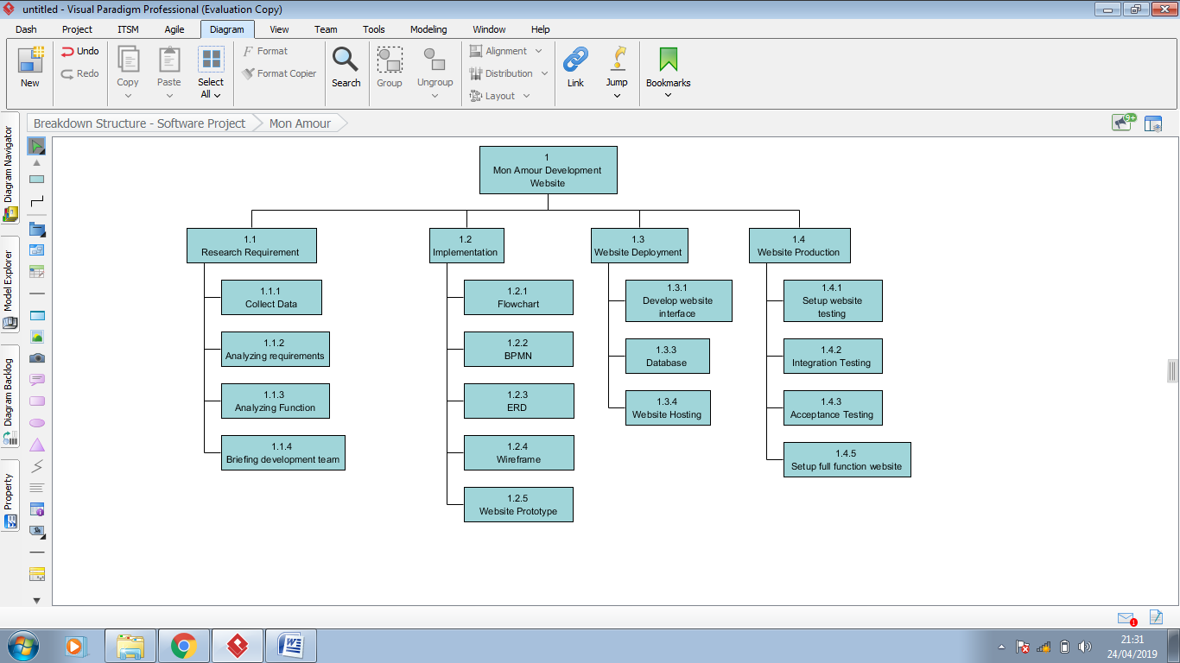**Work Breakdown Structure for Mon Amour Dating Website**